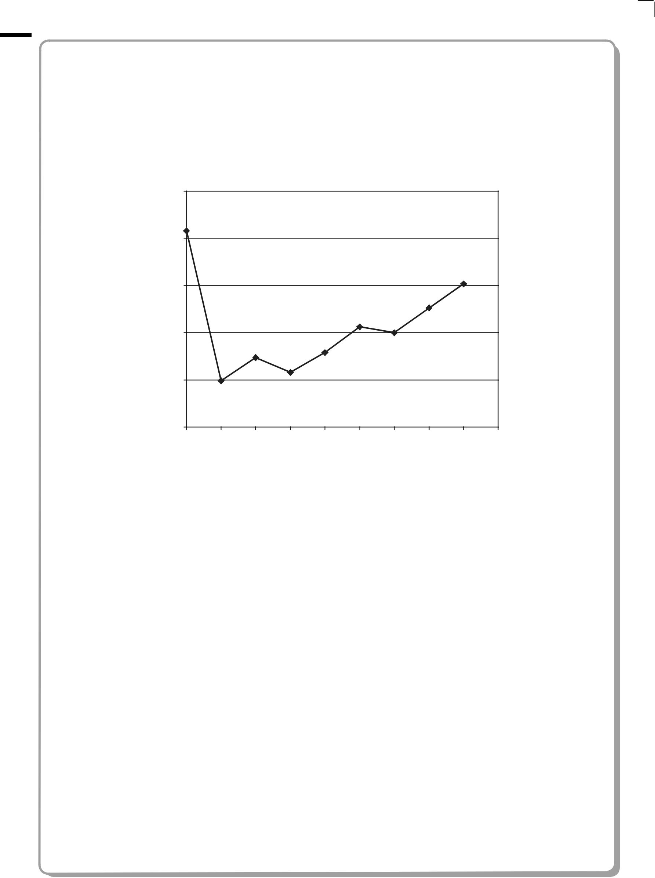**SECTION B**

**Answer ALL the questions. Write your answers in the spaces provided.**

1. The first ionization energy of each of the elements from neon to argon is shown on the graph below. The first ionization energy of potassium has been omitted.

2500

2000

1500

Ionization

energy /

kJ mol–1 1000

500

0

Ne Na Mg Al Si P S Cl Ar K

Elements

1. Define the term **first ionization energy**.

**(3)**

................................................................................................................................................................................................................................................

................................................................................................................................................................................................................................................

................................................................................................................................................................................................................................................

................................................................................................................................................................................................................................................

................................................................................................................................................................................................................................................

................................................................................................................................................................................................................................................

**10** *P38433A01024*



1. Explain why, in moving from Na to Ar, the general trend is for the first ionization energy to increase.

**(3)**

................................................................................................................................................................................................................................................

................................................................................................................................................................................................................................................

................................................................................................................................................................................................................................................

................................................................................................................................................................................................................................................

................................................................................................................................................................................................................................................

................................................................................................................................................................................................................................................

(c) Explain why the first ionization energy decreases from P to S.

**(2)**

................................................................................................................................................................................................................................................

................................................................................................................................................................................................................................................

................................................................................................................................................................................................................................................

................................................................................................................................................................................................................................................

1. Estimate the value of the first ionization energy of potassium, K, and write your answer below.

**(1)**

................................................... kJ mol–1 **(Total for Question 16 = 9 marks)**